**ASSIGNMENT : DQL STATEMENTS**

**SUBJECT : DBMS(THEORY)**

**ROLL NO : 24BSAI29**

**SUBMITTED BY : SYED MUHAMMAD QASIM**

**SUBMITTED TO : Ms. Sana Faiz**

Mehran University of Engineering and Technology Jamshoro

**TASK A**

1. **Retrieving Data with SELECT Statement:**

* **SELECT empno, ename, sal * 12 AS "Annual Salary" FROM emp;**

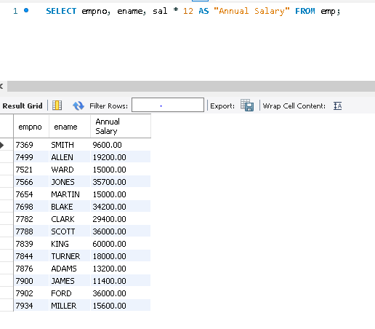

**TASK B**

1. **Find errors:**

* **Select empno, ename sal x 12 Annual Salary From emp;**

**Corrected Query:**

* **Select empno, ename, sal * 12 AS "Annual Salary" FROM emp;**

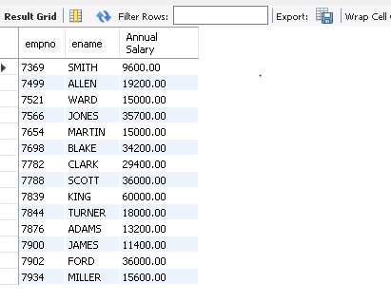

1. **Display employees’ annual salary with a one-time bonus of $100.**

* **Select empno, ename, (sal * 12) + 100 AS "Annual Salary with Bonus" FROM emp;**

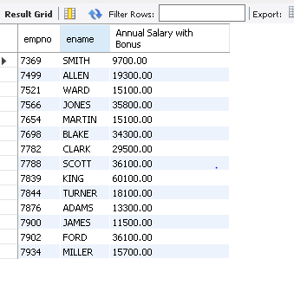

1. **Display annual compensation as monthly salary plus a monthly bonus of $100.**

* **Select empno, ename, (sal + 100) * 12 AS "Annual compensation " From emp;**

1. **Display rows in following format:**

**Monthly Salary**

**King: 1 month Salary = 5000**

* **Select concat(ename,": 1 Month Salary = ",sal) AS "Monthly Salary" From emp;**

1. **Display kinds of Jobs available in employee table.**

* **select distinct job from emp;**

**TASK C**

1. **Using WHERE Clause for Filtering Data:**

* **Find all employees whose job is not CLERK and belong to department 20.**

**Select ename from emp where (job!="CLERK")And Deptno = 20 ;**

**• Display the employee’s name , job title & salary based on the following criteria:**

**a) If the employee is a salesman, then he should be included in the O/P**

**b) If the employee is a manager, then his salary package must be above 2450.**

* + **Select ename, job, sal From emp Where job = 'Salesman' OR (job = 'Manager' And sal > 2450);**

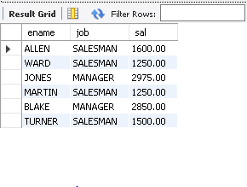

**• Display employee’s name , Job titles & salary if the employee is either a salesman or a manager & earns more than 2450.**

* + **select ename , job, sal from emp where (job = "SALESMAN" OR job = "MANAGER" )AND sal>2450;**

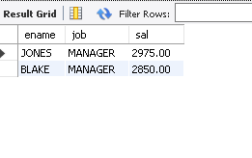

**TASK D**

**• List the employees having at least two A’s in their names.**

* + **select * from emp where ename like '%A%A%';**

**• List the employees whose names start with S and end at H.**

* + **select * from emp where ename like 'S%%H';**

**• List the employee whose name has E as the second character.**

* + **select * from emp where ename like '_E%';**

**• Display employ number and job title of all employees who have a job title that contain the string ‘MAN’ & earn more than 10,000.**

* + **select empno, job From emp Where job Like '%MAN%' And sal > 10000;**

**TASK E**

* + **Display list of employees who are either a clerk or an analyst & who do not earn 1000, 3000,5000.**
    - **select ename,job,sal from emp where job in ('CLERK','ANALYST') AND (sal!=1000 AND sal!=3000 AND sal!=5000);**

**TASK F**

**Display the names of employees according to their seniority.**

* + **select ename ,hiredate from emp order by hiredate asc;**

**Display names and annual salary of all employees, also sort the result based on annual salary in descending order.**

* + **select ename ,(sal*12) As "Annual Salary" from emp order by (sal*12) desc;**

**• Write a query which produces the following output.**

**S.NO ENAME DEPTNO SAL**

**1 KING 10 5000**

**2 CLARK 10 2450**

**3 MILLER 10 1300**

**4 SCOTT 20 3000**

**5 FORD 20 3000**

**6 JONES 20 2975**

**7 ADAMS 20 1100**

**8 SMITH 20 800**

**9 BLAKE 30 2850**

**10 ALLEN 30 1600**

**11 TURNER 30 1500**

**12 MARTIN 30 1250**

**13 WARD 30 1250**

1. **JAMES 30 950**
   * **select ename,deptno,sal from emp order by deptno asc,sal desc;**

